New Bern High School Health Science Curriculum Class: Health Science 2
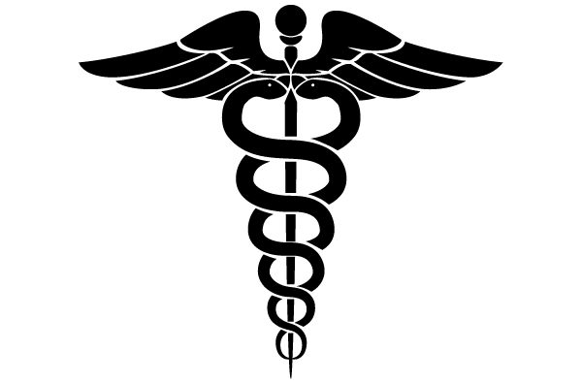Teacher: Jill Best Email: jill.best@cravenk12.org http://jbestnbhs.weebly.com/
Welcome to my class! Health Science 2 is an exciting class where we learn dig in a little deeper into the medical field. Please see class information below and fill out the second page with student information and best daytime contact information. I love and welcome communication with parents. If there is anything that comes up or questions you may have please don’t hesitate to contact me by email or at the school. Hoping for a great semester
*What will we discuss this semester? Class is divided into 13 sections:

- Healthcare Standards
- Communication
- Agencies, Insurance & Trends
- Legal & Ethical
- Teamwork & Leadership
- Wellness
- Safety
- Infection Control
- Diagnostic & Therapeutic Services
- Health Informatics
- Support Services
- Biotechnology
- CPR & First Aid

***Each section will end with a test (totaling 13 tests in all for the semester – *vital signs is a separate section & practiced all year). In this class there is a variety of teaching methods including PowerPoints, group work, class presentations, worksheets & various classwork,& occasional homework. The Health Science 2 students will also “run” the blood drive on Friday Jan. 29th.
*Maturity
This class is preparing students to be professionals. In order to do this we discuss mature topics and I expect students to handle this with maturity and respect for the topics. The information that is discussed is strictly related to the curriculum and if you have any questions about this please don’t hesitate to contact me!
*What are the classes after Health Science 2?
If you enjoy this class, & think you want to learn more – then the next steps in the Health Science pathway is Public Health Fundamentals and Nursing Fundamentals which is a CAN course that is potentially coming to New Bern High School Next school year.
*What Supplies will I need?
For the best organization in this class I recommend a ½ - 1 inch notebook full of lined notebook paper with 13 dividers. Notecards or “Quizlet” app would be beneficial for various terminology. Students can use paper, or electronic devices for notetaking. Also for the blood drive Red, Black, or a combo of each scrubs are needed for that day.
*Scrub Days
Scrub days are every Wednesday. Students are allowed to wear scrubs for extra credit (10 point extra credit assignment every week). Scrubs must be worn all day and without sandals to receive full credit.For the blood drive, students are required to wear scrubs and black/red is preferred.
Extra Credit
Beside scrub days, students will receive an extra credit card to keep with them at all times. I give lots of opportunity to receive extra credit: review games, turning projects in early, going above and beyond what is expected, and others. The other way students can earn extra credit is donating classroom supplies. Supplies my classroom uses the most are dry erase markers, tissues, & hand sanitizer.

