Health Science 1 – Body Part ABC Book

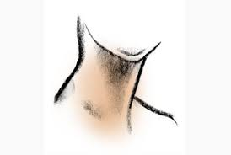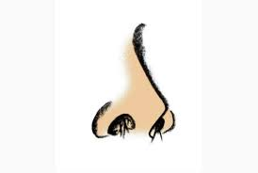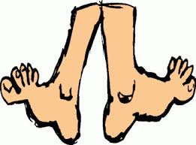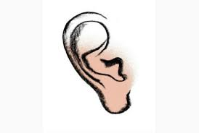

Purpose:
Students will create an ABC book including any body part that we have or will discuss this semester.
Organization:
Project will be in book form with content only on front side of each page. Book needs to have a cover page that includes your name. Last page should be your graded rubric. Each page will have two letters (Ex: A on top half and B on bottom half of page). Each letter needs to contain:
- Letter
- Body Part (.5 point)
- Section of the body part is found (skeletal, muscular, etc..) (1 pt)
- Part description/function (function, made up of, etc..) (1 pt)
- Small picture (can be computer generated or drawn) (1 pt)
- Disorder associated with that body part and brief description/tx

Rubric

 | Student Points | Teacher Points
Project Organization  *On time, legible, cover page & rubric included 2 letters per page etc… | /9 | /9
Letters
letter included with a picture, section of body, description/function, tx
A | /3.5 | /3.5
B | /3.5 | /3.5
C | /3.5 | /3.5
D | /3.5 | /3.5
E | /3.5 | /3.5
F | /3.5 | /3.5
G | /3.5 | /3.5
H | /3.5 | /3.5
I | /3.5 | /3.5
J | /3.5 | /3.5
K | /3.5 | /3.5
L | /3.5 | /3.5
M | /3.5 | /3.5
N | /3.5 | /3.5
O | /3.5 | /3.5
P | /3.5 | /3.5
Q | /3.5 | /3.5
R | /3.5 | /3.5
S | /3.5 | /3.5
T | /3.5 | /3.5
U | /3.5 | /3.5
V | /3.5 | /3.5
W | /3.5 | /3.5
X | /3.5 | /3.5
Y | /3.5 | /3.5
Z | /3.5 | /3.5
Extra  Turned in early, anything above & beyond, etc… | +____ | +____
Total | /100 | /100

