HS1 – Digestive Mini Project
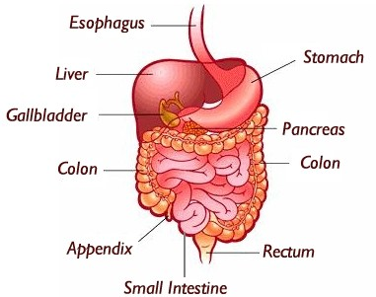
Instructions:
-You will display the digestive system and its components in “real world” way (ex: my example of a train and its track).
Needs to include:
-All digestive system parts of the GI Tract (in order) and Accessory organs.
-Each part labeled with its function
What will I be graded on?
-All parts included and in the correct order and function
-Creativeness of your idea and execution of it
Rubric | Points
All parts included & in order, labeled and includes its function | /60
Creativeness & Execution | /20
On Time, Anything Extra, Overall | /20

